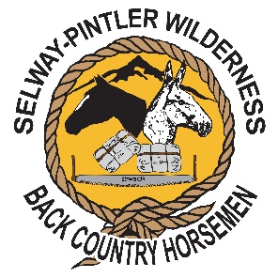**Montana Matters Youth Outdoor Experience**

Location: Magruder Ranger Station, Frank Church River of No Return Wilderness

The Selway-Pintler Wilderness participated in a youth camp hosted by a group of conservation organizations that is known as the Montana Matters Youth Outdoor Experience. Kids put in for a chance to go to Magruder, along with other camps around the state, at an event held in May at the Ravalli County Fairgrounds in Hamilton, MT in May.

The SPWBCH was awarded a grant from BCHA in the amount of $150 which was used for the purchase of BCH Youth Packing booklets and individual drink cups for each of the students. Twenty kids spent the morning of July 9 learning about stock packing, mantying, preparing for a pack trip, Light on the Land, high lining, reading maps and horse safety, along with other interesting conversations that center around the back country.

The students had hands on with many of the topics and it is hoped that some of the kids will become stewards of the land as they grow up!

Thanks,

Kathy Hundley

Kathy Hundley

SPWBCH President and camp instructor/Stephanie Sipe, camp instructor

