Introducing BCHA’s NEW

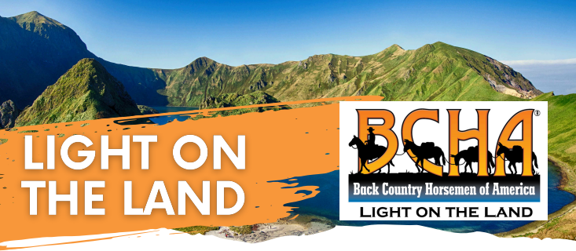

“Light on the Land” Stock Users Education Program

We have been following the Leave No Trace (LNT) program that was created by the US Forest Service in the 1960’s, when recreation on public lands increased significantly, with a corresponding level of damage to those wild places. Then in the early 1990s, the Forest Service worked with the National Outdoor Leadership School to develop hands-on, science-based minimum impact education for non-motorized recreational activities. To educate, encourage, and solicit active participation in the wise and sustaining use of the back country resources by horsemen and the general public.
This statement is the basis for the BCHA’s New program for stock use in the back country. This program has a lot of similarities with the LNT program but is more focused toward stock use.
The focus of our future trainings and education activities will follow the same seven LNT Principles:
- Plan and prepare
- Travel and camp on durable surfaces
- Dispose of waste properly
- Leave what you find
- Minimize campfire impacts
- Respect wildlife
- Be considerate of other visitors

