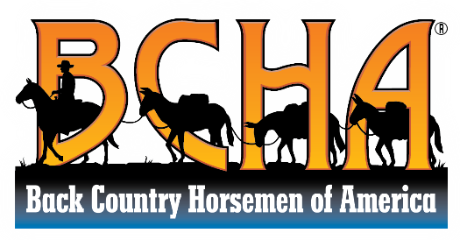

BCHA Mission Statement

Back Country Horsemen of America is a 501(C) 3 non-profit organization dedicated to the following mission.
• To perpetuate the commonsense use and enjoyment of horses in America’s back country and wilderness.
• To work to ensure that public lands remain open to recreational stock use.
• To assist the various government and private agencies in their maintenance and management of said resource.
• To educate, encourage and solicit active participation in the wise use of the back country resource by horsemen and the general public commensurate with our heritage.
• To foster and encourage the formation of new state Back Country Horsemen’s organizations.

